

California State University of San Marcos

Jordan Fisher, Juan Gonzalez, Keith Gross, Miguel Morales , Noah Miera

CIS490 : Dr. Shaun-inn Wu

### Table of Contents

1. **Application development**

1.1 Statement of Business Context 4

1.2 Statement of Customer’s Business Problem 4

1.3 Statement of Project Proposal 4

1.4 Statement of Deliverables 4

1.5 Measures of Success 5

1.6 System Overview 6

1. **Requirements Matrix** 6
2. **Project Management**

3.1 Product Breakdown Structure 7

3.2 Work Breakdown Structure 8

3.3 Initial Schedule for Tasks and Deliverables 9-11

3.4 Statement of Total Price 11-12

3.5 Gantt Chart 12-16

3.6 Initial Project Cost Tracking Chart 17

3.7 Statement of Deliverables 18

3.8 Outline of Resources Needed 18-19

1. **Team - Appendix**

4.1 Access to Project 19

4.2 Sprint Meeting Minutes 20-24

To: Jared Macshane, Machine Learning Supervisor

CC: Dr. Shaun-inn Wu, Director of Projects

The Sushi Team is grateful to be able to be part of this for Keep America Beautiful. Thank you Jared, as well as Dr. Wesley Schultz, for not only this opportunity to work in the Machine Learning field for this project, but also to work on something that helps build and maintain clean, green, and beautiful spaces in America. We look forward to working and learning from you this Spring semester of 2022, in order to assist in the making of this project.

In this second phase, the team conducted research and sought confirmation on additional requirements and resources needed for our Machine Learning project for Keep America Beautiful. Such progress so far has led us to conversing with the Web App team on initial Google Street image collecting needed for future training and testing of our algorithm, as well as looking at previous semester’s Google Street image datasets. Additionally, we are going over our options of pre-trained models to detect litter within said Google Street images, and solidifying an annotation tool that can be utilized by Dr. Schultz’s students to label litter within the Google Street images provided to us by the Web App team, which we will need for the training and testing of our algorithm. In the coming phase, we will strive to delve deeper into the implementation and development of our Machine Learning algorithm’s script, as well as its initial training and testing through a YOLOr object-detection model to detect litter within Google Street images.

Regarding the projected cost of this project, the Sushi Team has determined that we will “charge” a rate of $23 per hour, per member of our team. In this second phase, we have accumulated a cost of $3,074.50, through 132.5 hours so far. In the next phase, we estimate a cost of $4,772.50, through 207.5 hours. With this rate in mind, we estimate the total cost of the project to come to a total of $16,082.75, through a total projected 699.25 work hours in the end. With additional estimated monthly costs of a Google Cloud server, $50 per month, for the 4 months of development, this will total out to $16,282.75. Should alternative or additional costs be required, the costs will be updated accordingly.

By signing below, you hereby approve Sushi Team to continue working on the following project: Keeping America Beautiful: Litter Detective and agree to the aforementioned estimated costs.

From, Team/Scrum Leader: Noah Miera

_________________________________________

*Jared Macshane, Machine Learning Supervisor*

### 1. Application Development

**1.1 Statement of Business Context**

Keep America Beautiful is a leading national nonprofit organization that inspires and educates people to take action every day to improve and beautify their community environment. They envision a country in which every community is a clean, green, and beautiful place to live.

**1.2 Statement of Customer’s Business Problem**

* Need a new Machine Learning algorithm to produce data on Google Street images containing litter.
* Needs the data to not only detect if there is litter, but also categorize them.
* Make the results available and usable for the Web App team.

**1.3 Statement of Project Proposal**

* 1. Process Google Street images through a pre-trained model.
* 2. Adapt model to our specific needs of litter detection.
* 3. Collect output data/results.
* 4. Sync up input/output format with the Web App team.
* 5. Make results accessible to the Web App team.

**1.4 Statement of Deliverables**

* Machine Learning code/algorithm that will be compatible and usable with the Web App team.
* Algorithm will produce data that will include:
  + Identification of litter in an image.
  + The total amount of litter.
  + Show the detection accuracy in testing (e.g. 90% sure this is a Plastic bottle-Litter).
  + *Striving for/Conditional features*:
    - Categorize the litter (e.g. Plastic bottle, Paper bag).

We will strive to deliver a new Machine Learning algorithm for Keep America Beautiful, developed through Python in a Anaconda/Miniconda environment, that will output usable and available results for the Web App team.

**1.5 Measures of Success**

The Sushi Team will perform the following tasks in order to accomplish the requirements listed in the proposal.

* JAD #1 - Identify initial requirements and technical specifications for the project.
  + Connect to a Google Cloud Server.
  + Establish Anaconda/Miniconda environment.
  + Read documentation/code of TACO’s pre-trained model.
  + Collect/Annotate Google Street images for future initial testing.
* JAD #2 - Identify the final requirements and technical specifications for the project.
  + Further collect Google Street images for future initial testing.
  + Establish extra student labor to assist in Google Street image annotations, and the access to software and Google Street images they will need.
  + Research object-detecting pre-trained model options for our detecting litter process.
* Prototype #1 - Process images through the Machine Learning algorithm to produce litter metrics.
* Prototype #2 - Able to sync up the input/output format of the Machine Learning algorithm with the Web App team.
* Final Product - Collation and transfer of litter metrics from images, received by the Web App team, that have been processed through a Machine Learning algorithm, for use by the Web App team.

**1.6 System Overview**

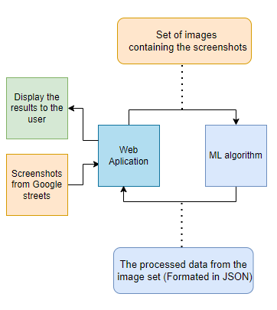

### 2. Requirements Matrix

| REQ # | Requirement name | Description | Critical | Implemented | Task ID |
| --- | --- | --- | --- | --- | --- |
| 1 | Process Google Street images | Google Street image datasets can process through a pre-trained model. | Y | N | 2.7.1 / 3.3.1  3.3.4 / 3.3.9  3.3.10 / 3.5.2  4.3.1 / 4.3.7 |
| 2 | Litter Detection | The algorithm will identify the presence of litter in Google Street images. Conditional: As well as classify them. | Y | N | 4.5.4  4.5.5 / 4.8.2  4.8.3 / 5.4.4  5.4.11 / 6.2.1 |
| 3 | Prepare Google Street Image Metrics | The Machine Learning program will process the algorithm’s litter results into JSON. | Y | N | 4.8.9 / 4.8.17  5.2.1 / 5.2.2  5.2.8 / 5.2.9 |
| 4 | Send Prepared Metrics | Once the results have been prepared, the program will deliver the metrics to the Web App team. | Y | N | 4.8.18 / 6.2.7 |

### 3. Project Management

**3.1 Product Breakdown Structure**

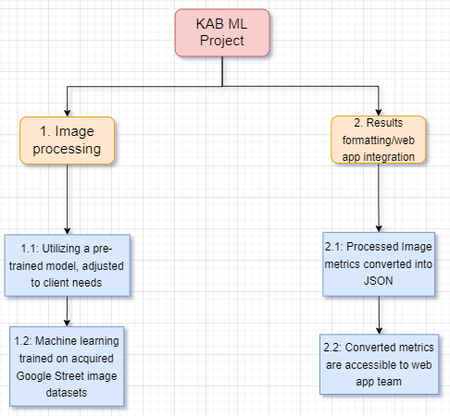

**3.2 Work Breakdown Structure**

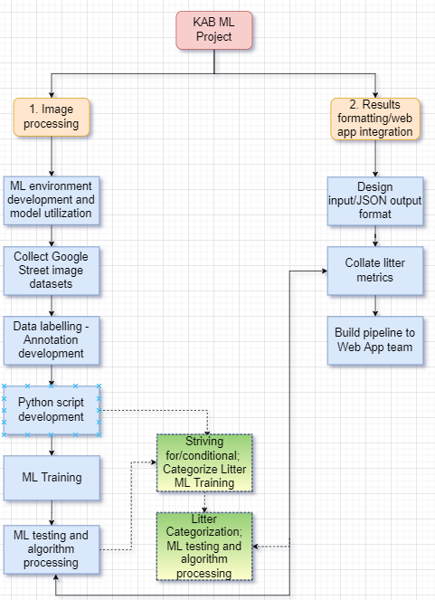

**3.3 Initial Schedule for Tasks and Deliverables**

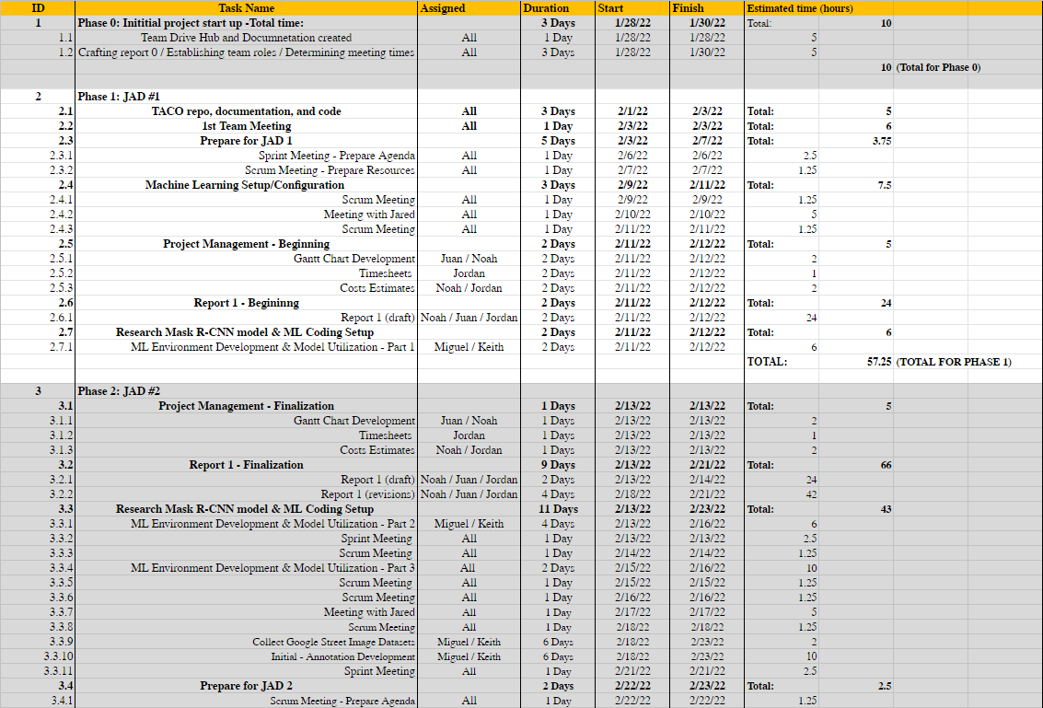

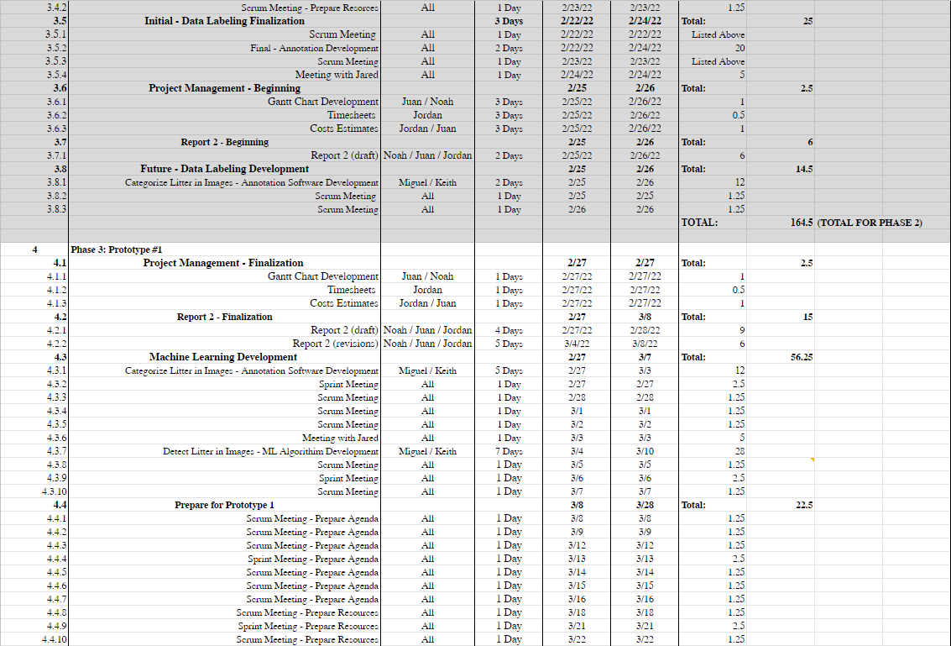

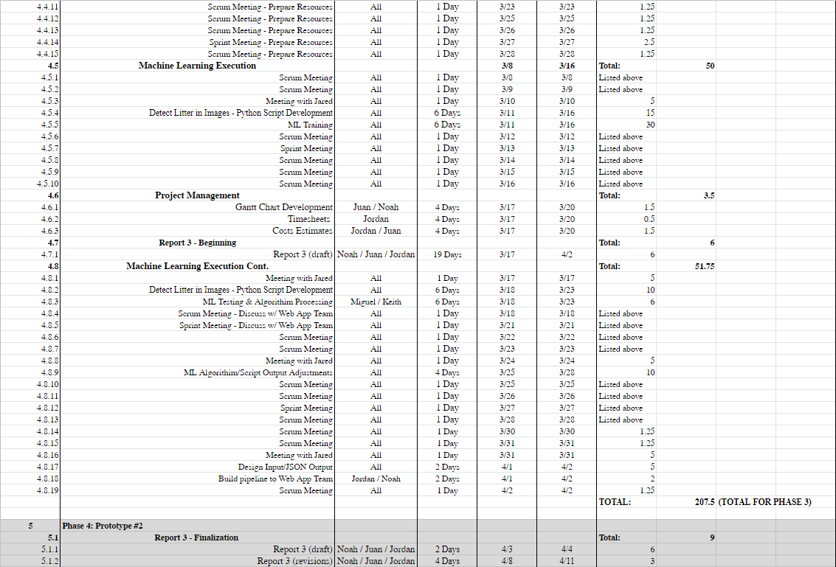

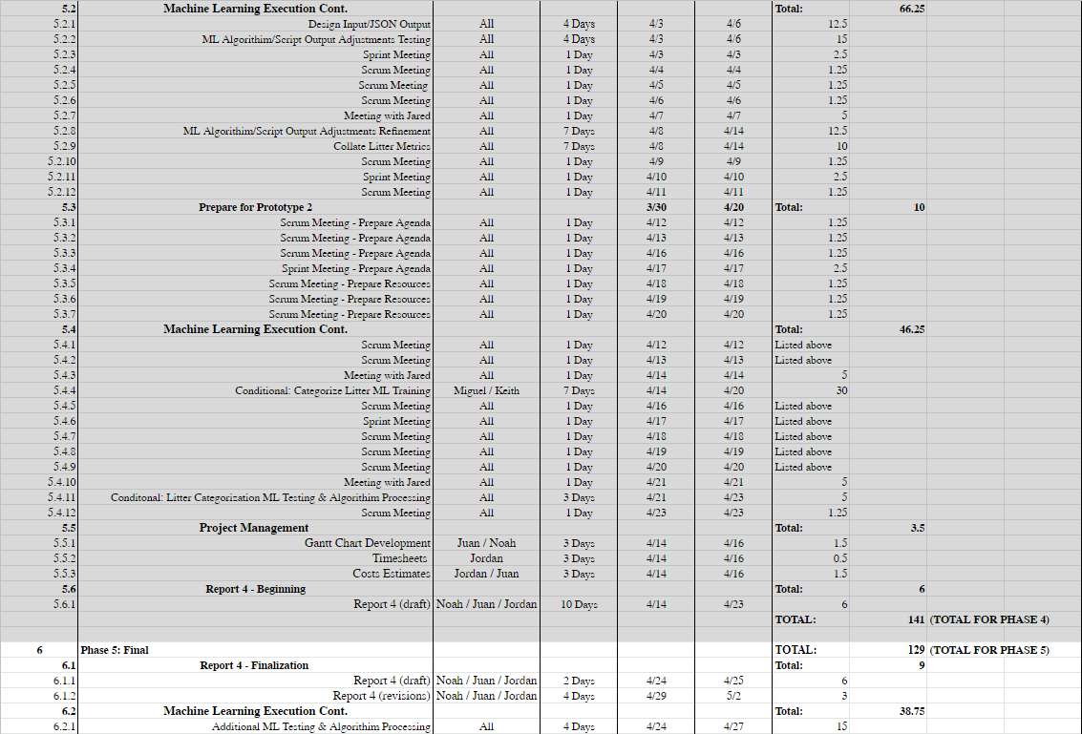

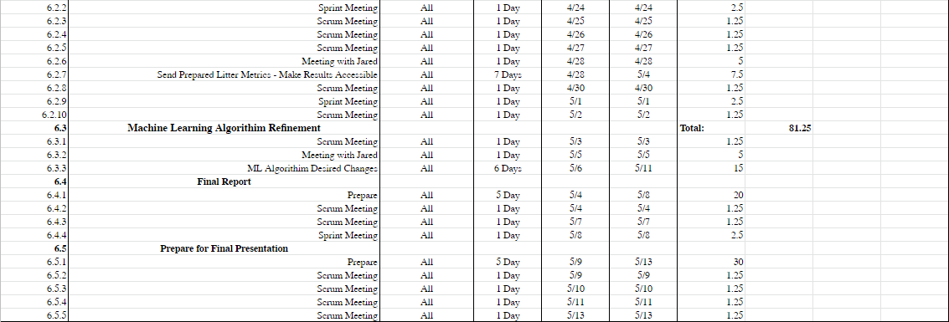

**3.4 Statement of Total Price**

We will be charging a flat rate of $23.00 per hour for each member of the Sushi Team. Through phase 1 of the project, it was estimated that the cost will be $1,316.75. This is based on an estimated 57.25 hours of work done by the team in this phase. In actuality, the cost was $1,138.50, having been completed in 49.5 hours of work.

During phase 2 all the members were estimated to work a combined total of 164.5 working hours. As such, the estimated cost for the phase was $3,783.50. In actuality however a total cost of $3,047.50 was accrued with a total of 132.5 hours.

During phase 3 of the project, the Sushi Team is projected to work for 207.5 hours. The cost will be $4,772.50 for the phase.

During phase 4 of the project, the total number of estimated working hours spent towards development amounted to 141 hours, with a cost of $3,243.00 total.

During phase 5 of the project, the total number of estimated working hours spent towards development amounted to 129 hours. Thus, the total cost for this phase will be $2,967.00.

The final cost of this project is projected to be $16,082.75, with 699.25 hours spent by the team towards the development of the litter detection algorithm. However, with additional estimated monthly costs of a Google Cloud server, $50 per month, for the 4 months of development, this will total out to $16,282.75. Should alternative or additional costs become required, these will be updated accordingly.

**3.5 Gantt Chart**

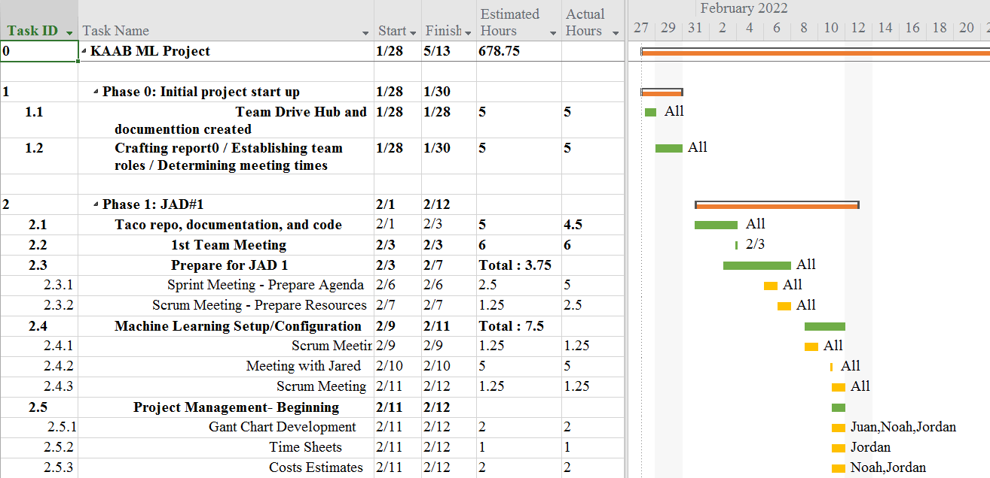

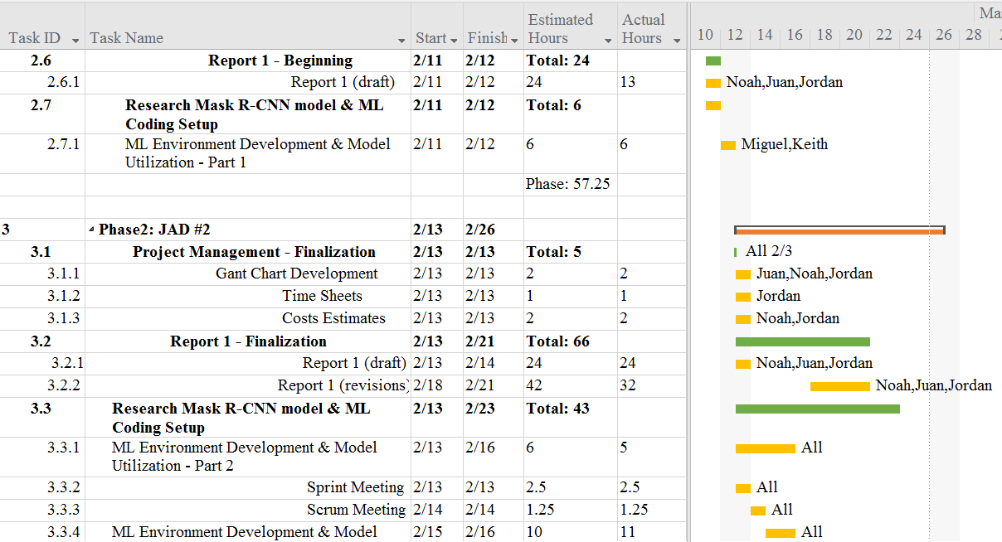

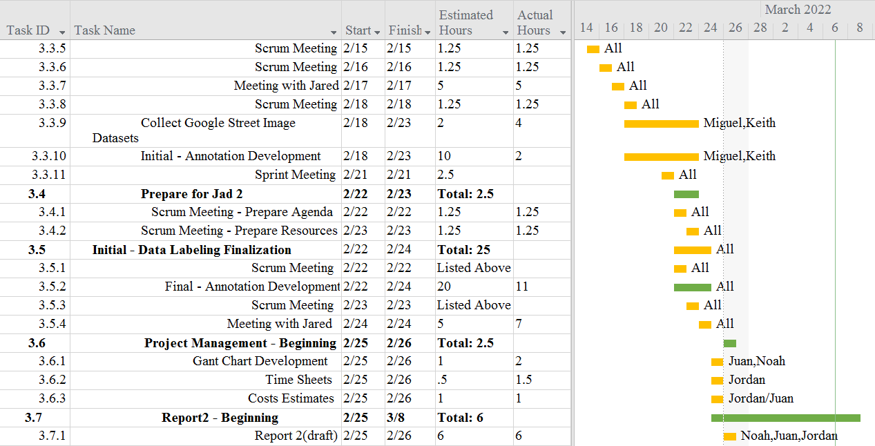

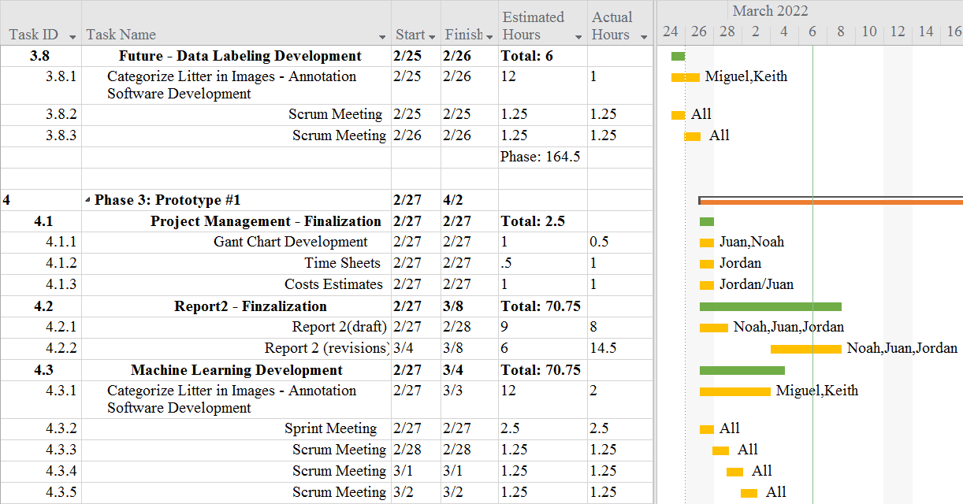

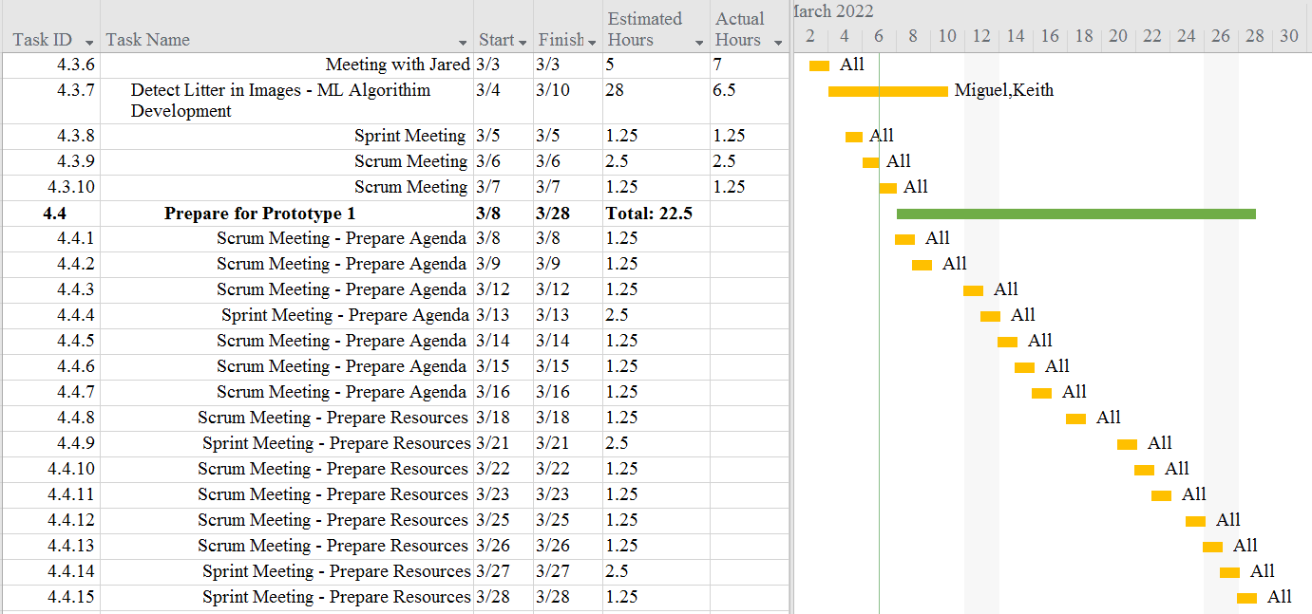

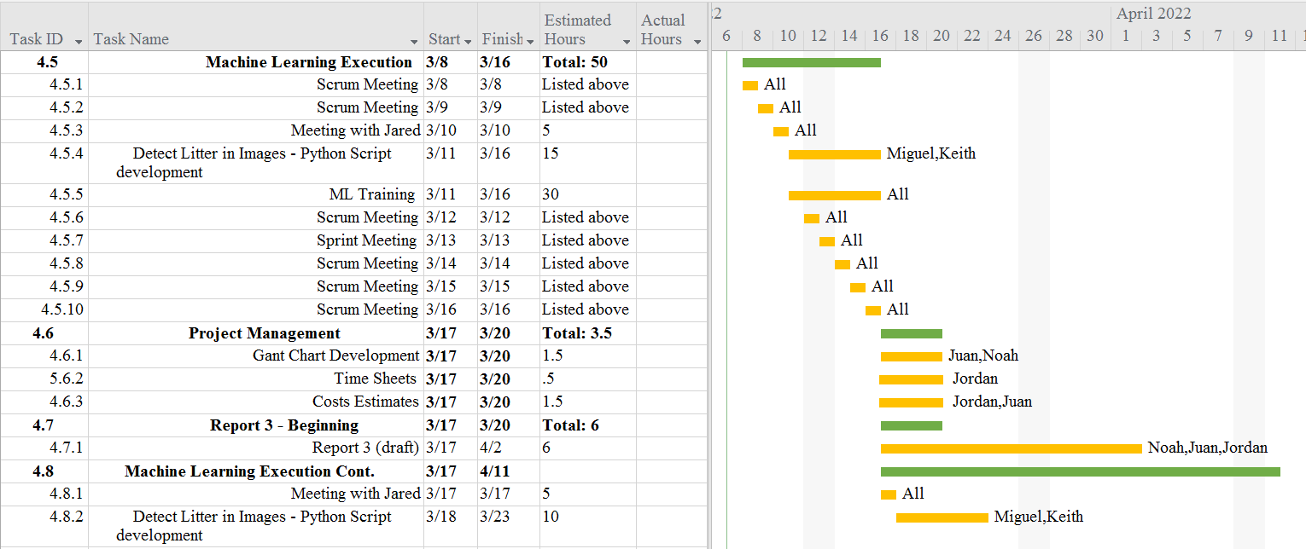

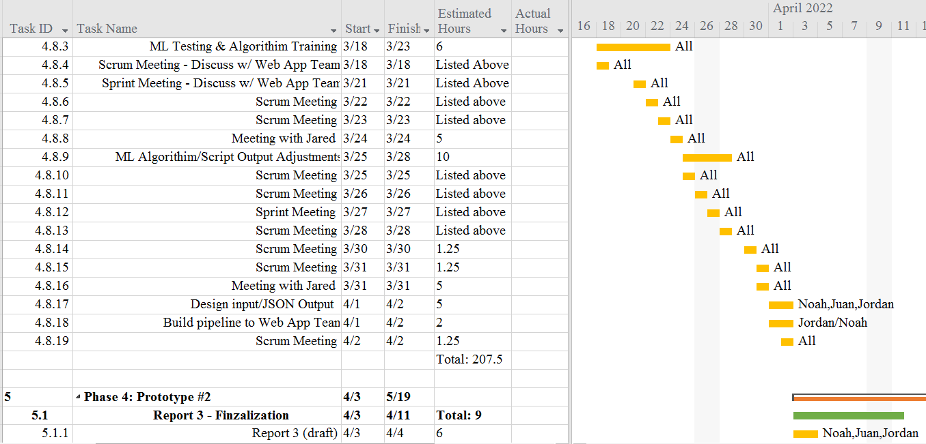

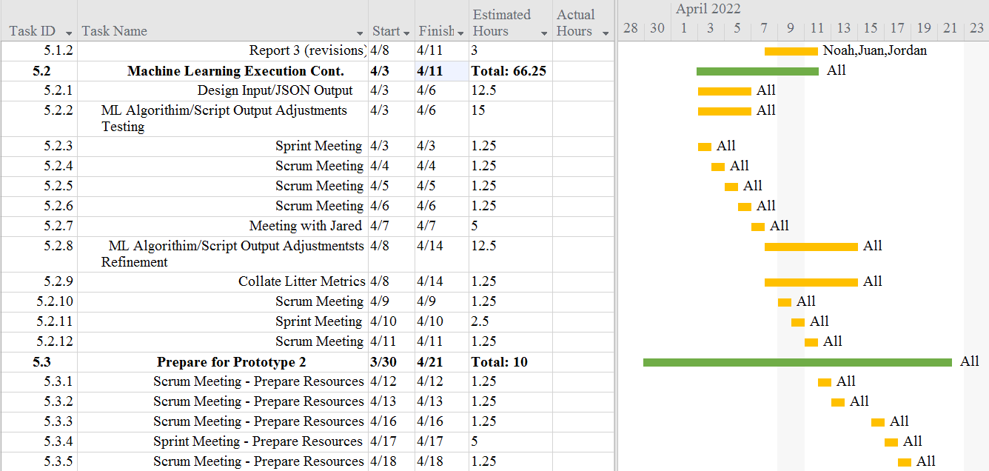

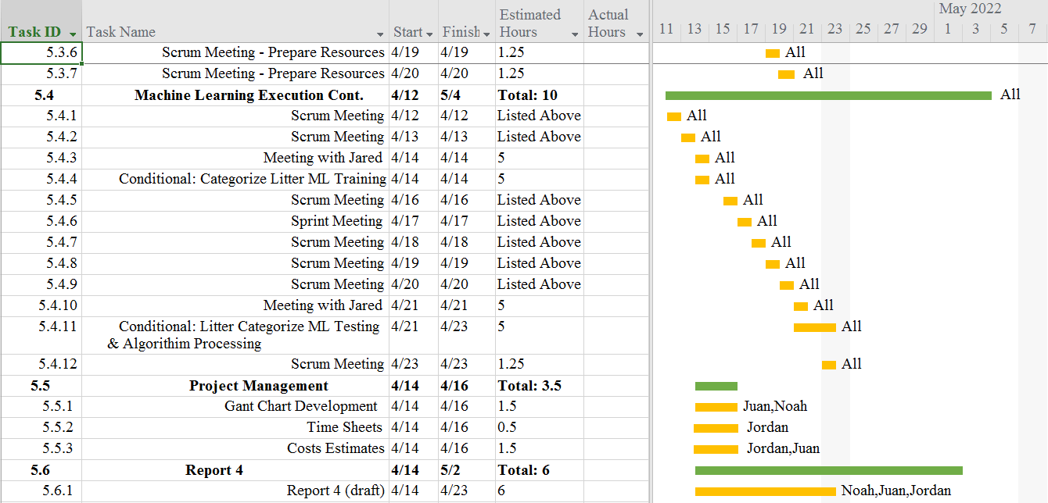

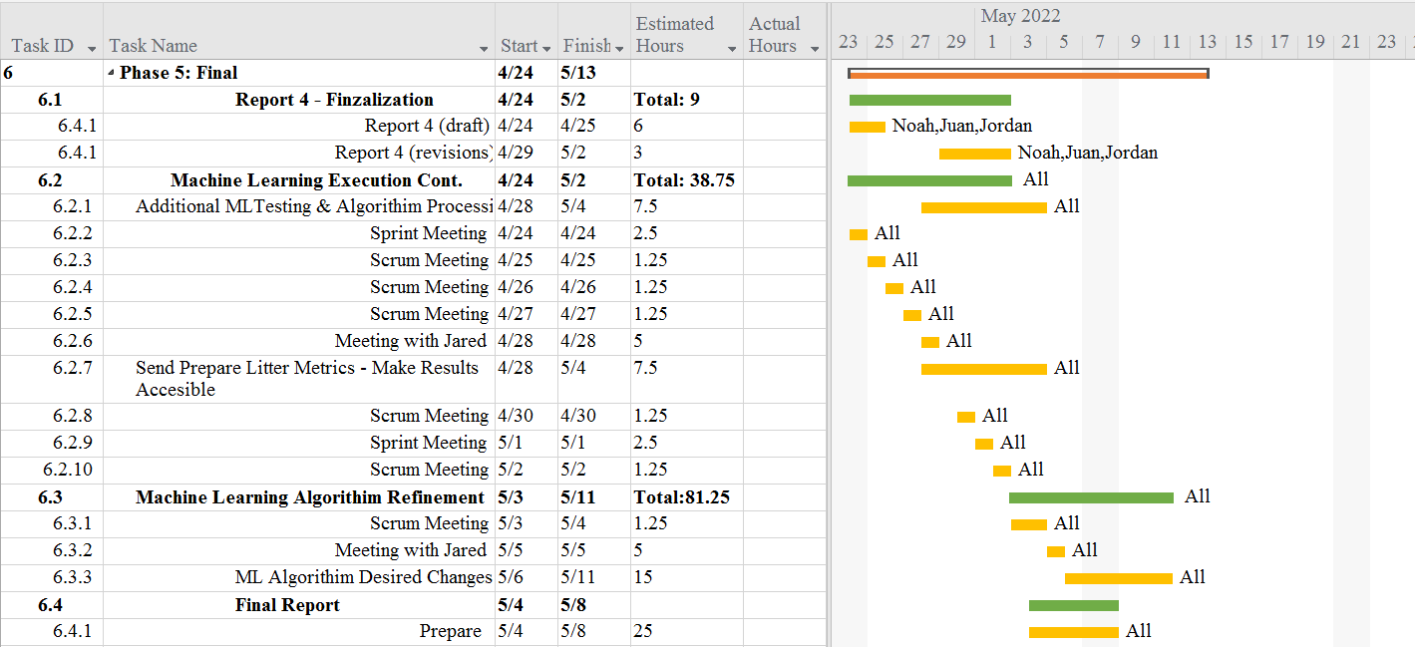

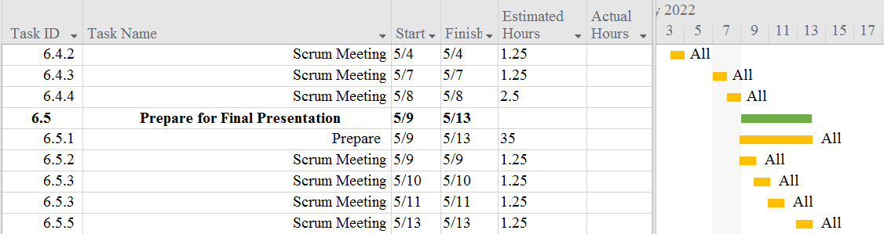

**3.6 Initial Project Cost Tracking Chart**

(As of now, by Phase 2)

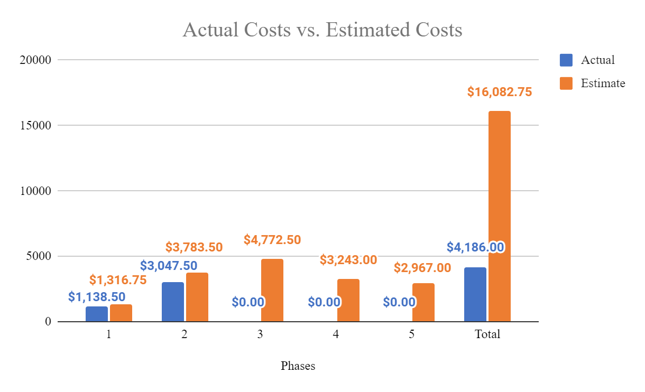

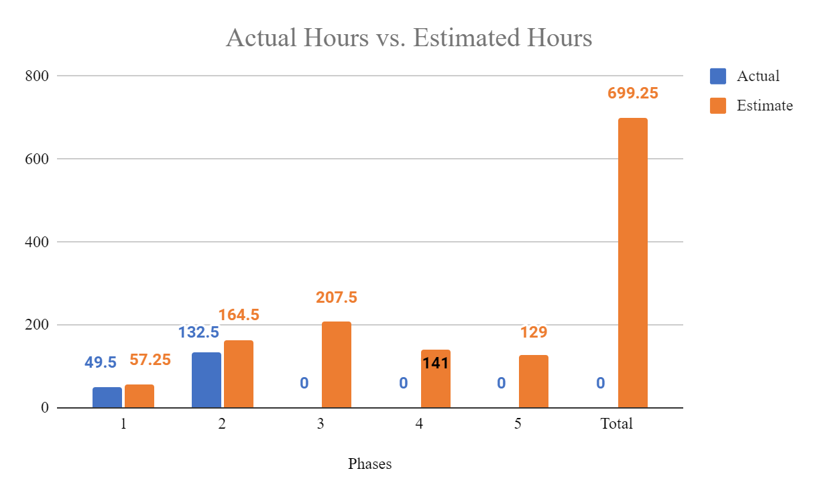

The above chart tracks the estimated and actual costs/hours for each phase of the project as well as our total accumulated costs compared to our estimated costs. We will assume an hourly rate of $23.00 per hour for this project, as we estimate to work a total of 699.25 hours.

**3.7 Statement of Deliverables**

The Sushi Team strives to deliver the following final products:

* A fully working machine learning algorithm that will detect instances of litter in an image. When executed, it will display the Street image with outlines of the litter that is visible, along with percentages based on the accuracy. We will also strive to, though conditional, identify the type of each litter instance.
* A scheduling hook by which the web app team can use this algorithm by sending a set of images.
  + A system to format the data collected from the set of the set of images sent using the web application.
  + A system to send the formatted data back to the web application for further use as determined by the web app team.
* A Github repository for the machine learning project/algorithm.
  + Source code for the algorithm.
  + Documentation, manuals, and reports for users and programmers.

**3.8 Outline of Resources Needed**

The following are what the Sushi Team will be supplying:

* Knowledge of Python code, documentation, and implementation.
* Updated documentation.
* Research and testing.

The following resources are what the Sushi Team will need supplied from Jared Macshane:

* References and guidance of Machine Learning through existing models & open-source data/source code/software.
* Google Cloud Server Instance and Funding.
* Signage and approval for the Sushi Team to continue working on the project.
* Availability for future meetings.
* Access to Keep America Beautiful’s private server.
* Possible extra student labor to assist in Google Street image annotations for Google Street image datasets.

### 

### 4. Team - Appendix

**4.1 Access to Project**

The following will be how the Sushi Team will be collarbaring during this project so-far:

* Discord.
  + https://discord.gg/dr5785e9
* GitHUB
  + https://github.com/JuanGonzalez2020/KAAB-ML
* Google Cloud Server Instance.
  + Access is granted by Jared by giving him your SSH public key.
  + ssh username@34.125.176.184

**4.2 Sprint Minutes**

Sushi Team Sprint #1 Meeting Notes

Sunday, 02.06.2022

# **Attendees**

Noah Miera: Team/Sprint Leader

Juan Gonzales: Project Manager

Jordan Fisher: Documentation/Training

Keith Gross: Programer

Miguel Morales: Programer

**Minutes:**

## 12:00PM: Review of Recent Team Efforts and Commitments

* Report 0 was successfully turned in
* Team reaffirmed that we will meet on the dates specified in report 0

## 12:10PM: Discussion of Team Roles

* Team member schedules and preferences were considered and the following Items were agreed upon:
  + Noah elected to take on role of Team/Sprint Leader
* Juan elected to take on role of Project manager
* Jordan elected to take on role of Documentation/training
* Keith and Miguel Elected to take on role of Programer
* Team reaffirmed commitment to assist each other even if scope of work did not exclusively match their individual role description

## 12:40PM: Discussion of Upcoming Tasks

* Noted that time went long, committed to improving sprint time in future
* Team contributed individual questions to JAD 1 agenda
* Date/time discussed for JAD 1.

## 1:00PM Meeting Adjourned!

Sushi Team Sprint #2 Meeting Notes

Sunday, 02.13.2022

**Attendees**

Noah Miera: Team/Sprint Leader

Juan Gonzales: Project Manager

Jordan Fisher: Documentation/Training

Keith Gross: Programer

Miguel Morales: Programer

# **Minutes:**

## 12:00PM: Review of Recent Team Efforts

* Report 1 draft is underway will need further work before turning it in

## 12:05PM: Discussion of recent developments

* Programers are continuing to research ML development environments
  + Keith has most of his figured out
  + Miguel is running into hardware issues that he will try to resolve
* Other 3 teammates have worked on the draft of report 1

## 12:15 PM: Discussion of Upcoming Tasks

* Keith and Miguel will continue to work on their environments
* Noah, Juan, and Jordan will continue to revise report 1
  + Availability discussed (Super Bowl parties will be sacrificed)

## 12:25 PM Review of and reminder to fill out timesheets

## 12:30 PM Meeting Adjourned!

Sushi Team Sprint #3 Meeting Notes

Monday, 02.21.2022

# **Attendees**

Noah Miera: Team/Sprint Leader

Juan Gonzales: Project Manager

Jordan Fisher: Documentation/Training

Keith Gross: Programer

Miguel Morales: Programer

# **Minutes:**

## 12:00PM: Review of Recent Team Efforts

* Report 1 final draft is almost complete, small edits remain

## 12:05PM: Discussion of recent developments

* Programers are continuing to work on getting annotation setups working
* Other 3 teammates have worked on the final draft of report 1

## 12:15 PM: Discussion of Upcoming Tasks

* Report 1 final revisions will be finalized by noah and then sent in
* Juan will deliver the hard copy
* Keith and Jordan will meet to discuss documenting the annotation process for if/when annotations are passed on to Dr. Schulz’s team

## 12:25 PM Small detail confirmation with team for editing report 1

## 12:30 PM Meeting Adjourned!

Sushi Team Sprint #4 Meeting Notes

Sunday, 02.27.2022

# **Attendees**

Noah Miera: Team/Sprint Leader

Juan Gonzales: Project Manager

Jordan Fisher: Documentation/Training

Keith Gross: Programer

Miguel Morales: Programer

# **Minutes:**

## 12:30PM: Review of Previous tasks & confirmation of actual times on timesheet

## 12:40PM: Explanation of VIA3 annotation software by Keith Gross

* Hosted online. All Dr. Schultz’s students would need to do is go onto the website and open the project with the correct project id
* Images can be added to the project
* Potential issue: importing images via URL is most effective, however they may need to be publicly hosted before they can be imported

## 12:51 PM: Discussion of Upcoming Tasks

* Keith and Miguel will be looking in to setting up VIA3 for Dr. Shutz’s students
* Noah, Juan, and Jordan will be working on report 3

## 1:00PM Meeting Adjourned!

Sushi Team Sprint #5 Meeting Notes

Sunday, 03.6.2022

# **Attendees**

Noah Miera: Team/Sprint Leader

Juan Gonzales: Project Manager

Jordan Fisher: Documentation/Training

Keith Gross: Programer

Miguel Morales: Programer

# **Minutes:**

## 12:00PM: Confirmation of time for meeting with Group 2 and Jared

* 1PM with Jared as well as Ray and Angelica from group 2
* Develop questions for that

## 12:05PM: Review of complete and upcoming revisions for report 2 revisions

* Group will reconvene at 3:30 to finalize any changes

## 12:07 PM: Checking in with programmers about XML to YOLOR annotation conversions

* Roboflow seems to work well,
  + however some of the annotations are sized poorly
    - Could be a product of the original annotators rather than the program itself
  + also allows for augmentations which may increase the number of images we functionally have
* Discuss the changes to old annotations with Jared

## 12:15 PM: Discussion of upcoming tasks:

Programers will follow up on converting old dataset to YOLOR and the preparation for the training

* Miguel will focus on the isaychris method
* Keith will prepare for the training phase

## 12:25 PM: Confirmation of meeting time tomorrow at 10:30:

## 1:00PM Meeting Adjourned!